Computational Methods

Explanation of sub-optimal approach has a reasonable argument, and includes mention of complexity of the approach, using big O notation. This is backed by an excellent level of research, in Harvard format. There is also a comparison of other approaches, along with discussion of their complexities in big O notation.

Task 1
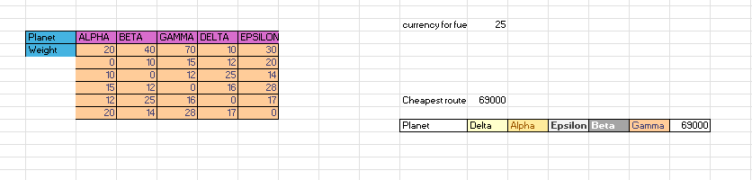

After running it through the whole brute forcing process, we can say that this is an inefficient way to solve this calculation because of the amount of time we take to find the cheapest solution (as it’s showed in the spreadsheet and the code for it). Going through all the possible combination in this case for 5 planets and gives me a O(n!), because I need to check the planets one by one in a factorial way so 5*4*3*2*1 = 120 combinations for this problem.
As seen during my research an algorithm with o(n!) requires high amount of time and is unusable for large input sizes.
Doing a bit more research into the brute-force I can say that there isn’t really any other O notations or ways to do it in a faster way because we want to get the cheapest value taking in weight, distance and fuel cost, taking in consideration that every planet we visit it will become heavier depending on the planet we are on, the best way to describe it would be an equation cost(D,W) = distance * weight* fuel cost.

(10/11/2025) Medium: Mastering Big O Notation: https://medium.com/@sureshkumar.pawar/mastering-big-o-notation-a-comprehensive-guide-to-understanding-algorithm-efficiency-8d77d79384e1

